My Career Choice

By

Austin Deane

IT 110C

IT in the Global Age

Marymount University

September 15, 2019

Table of Contents

Introduction 3

Occupation Fit, Skills & Interests 4

Describe Your Occupation 4-5

Education & Training 5

Pay Scale 5-6

Notable Person(s) 6-7

Journals/Associations of Interest 7

Conclusion 8

References 9

# Introduction

Hello and welcome. My name is Austin Deane and right now I am currently a student at Marymount University who is aspiring to be an information security analyst. Information Security Analysts are people who plan and are prepared for cyberattacks, specifically for companies or organizations. Information security analysts protect computer and network systems. They also monitor their computer network for security breaches along with installing software and encrypting programs. Today, information security analysts are critical and vital because there are so many hackers now on the internet always coming up with new ideas and companies and organizations need someone to protect them and that's exactly what information security analysts do. (Bureau of Labor Statictics, 2019).

# Occupation Fit, Skills & Interests

Some of my skills include critical thinking, IT services, online marketing, along with IT Infrastructure Management. Also, I love technology and I have an interest in preventing hackers and helping out the world with my skillset in any way that I can. This career currently fits the skills that I have because information security analysts are required to have critical thinking along with IT service skills to solve data breaches and stop hackers. (Doyle, 2019). Also, this career peaks my interest because I want to help make the world a better place in any way that I can and I feel that these skills I have can help do that in the form of me being an information security analyst.



Figure (Austin Deane)

# Describe Your Occupation

For my occupation as an information security analyst, I will do a lot of IT work involving the installation and use of software, keeping track of the latest IT trends and information along with solving data breaches and stopping hackers. Also, I'll have to stay on my toes in the sense that I should always be monitoring computer systems and making sure that everything is running smooth. (Bureau of Labor Statictics, 2019). Furthermore, I would have to create a disaster recovery plan for my IT department in case if something were to go down or happen. (U.S. News and World Report, 2019).

# Education & Training

For this occupation, I will need a Bachelor's Degree in either computer science, computer programming, or another computer related field. (U.S. News and World Report, 2019). Also, some employers even prefer to have its applicants have a Master of Business Administration, or, MBA, in information systems. Also, people who aspire to be an information security analyst will need to have some experience such as being a computer or network systems administrator in the information technology, or, IT, department. According to the Bureau of Labor statistics, in 2018, there were over 100,000 people in its workforce. (Bureau of Labor Statictics, 2019).

# Pay Scale

If you are an information security analyst, the pay scale for it is very good and in 2018, the median pay was $98,350 a year or, an average salary of $47 an hour before taxes. According to the Bureau of Labor Statistics, from 2018 to 2028, there should be a 32 percent job increase for this field. Also, there is believed to be an employment change with a population increase of over 30,000 employees. (Bureau of Labor Statictics, 2019). Furthermore, this is the pay that I was expecting because many jobs involved in the STEM field pay their and compensate their employees very kindly.

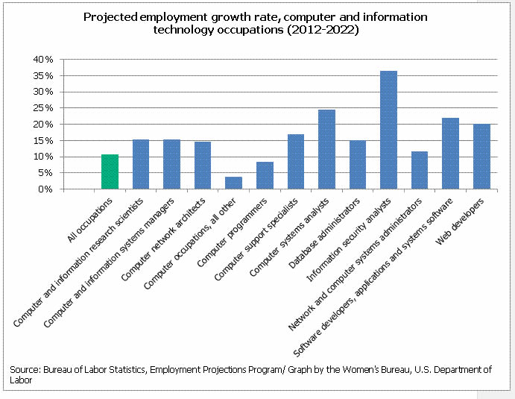 (U.S. Department of Labor, 2015).

Figure (Projected Employment Growth Rate)

# Notable Person(s)

In the cyber field, one notable and influential person is Richard Bejtlich. Richard Bejtlich is a cyber-security summit speaker and he is currently the Chief Security Strategist at FireEye. Bejtlich’s job is to apply critical thinking and skills into private sector cyber defense. He began his career in 1997 working with the military as a digital security officer. Since then, Bejtlich has become a prominent name in the cyber world and has written numerous novels pertaining to this topic. (Cyber Security Summit, n.d.). While I do not have any connections to Richard Bejtlich, he is a great resource and a great role model for my career as an information security analyst.

# Journals/Associations of Interest

One notable association that would be great and work well for my career would be the SANS Institute. (SANS, n.d.). The SANS Institute is an organization that was founded in 1989 and it is a source for information security training and it has developed multiple online courses that also train people for cybersecurity, network attacks, and so much more. (WhatIs.com?, 2016). Additionally, I could perhaps be involved by signing up for some of their courses that could help train and prepare me for this occupation. Below are the links for these great associations of interest.

<https://www.sans.org/>

<https://whatis.techtarget.com/>

# Conclusion

In conclusion, information security analysts are a necessity for today's society. You may ask yourself why, but first, let me explain. With how fast and rapid the internet is changing nowadays, companies need to have online security more than ever to prevent hackers and stop data breaches. (Doyle, 2019). Also, without information security analysts, companies and organizations could face a lot of damage and online threats. (Bureau of Labor Statictics, 2019). Furthermore, these are all just some examples as to what information security analysts do and why they are an important necessity for our ever-changing online world.

# References

# References

Bureau of Labor Statictics. (2019, September 4). *What Information Security Analysts Do*. Retrieved from U.S. Department of Labor: https://www.bls.gov/ooh/computer-and-information-technology/information-security-analysts.htm#tab-2

Cyber Security Summit. (n.d.). *Richard Bejtlich*. Retrieved from Cyber Security Summit: https://cybersummitusa.com/speaker/bejtlich-richard/

Doyle, A. (2019, March 15). *Information ecurity Analyst Skills List and Examples*. Retrieved from the balance careers: https://www.thebalancecareers.com/information-security-analyst-skills-2062409

SANS. (n.d.). *The most trusted source for information security training, certification, and research.* Retrieved from SANS: https://www.sans.org/

U.S. Department of Labor. (2015, August). *Computer and Information Technology Occupations*. Retrieved from U.S. Department of Labor: https://www.dol.gov/wb/stats/Computer_information_technology_2014.htm

U.S. News and World Report. (2019). *Information Security Analyst Overview*. Retrieved from U.S. News and World Report: https://money.usnews.com/careers/best-jobs/information-security-analyst

WhatIs.com? (2016, May). *SANS Institute*. Retrieved from WhatIs.com?: https://whatis.techtarget.com/definition/SANS-Institute

Figure 1 (Austin Deane) 4

Figure 2 (Projected Employment Growth Rate) 6